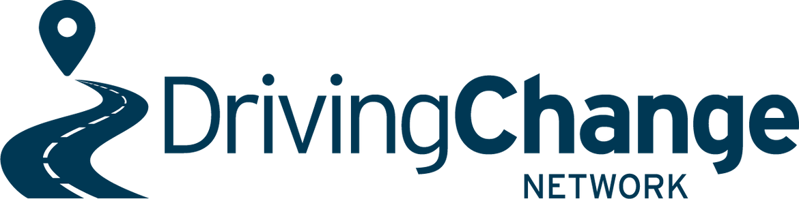

May 2, 2022

The Driving Change Network represent Community Driving Programme providers throughout New Zealand who work to assist people learning to drive who are unable to overcome individual barriers to gaining a full licence on their own. We submit on behalf of our membership that a Class 1 driver licence is more public good than private good, and should be funded accordingly. Key points to this include:
- Ensuring people have access to driver training and a class 1 licence enables people to meet their basic needs, including accessing work, healthcare, education and other basic services - reducing dependence on others and increasing overall societal productivity and wellbeing.
- Ensuring everyone possible progress to a full Class 1 driver licence also enables New Zealand to have a more productive workforce and lower benefit dependence.
- Barriers to driver licensing can lock in cyclical inequalities for families, such as inability to fund lessons, licence fees and to purchase and maintain a road-legal vehicle. This can affect their ability to move themselves and future generations into better employment opportunities.
- Families facing licensing barriers are more likely to become trapped in the Justice system through driver licencing infringements with many risking driving unlicenced.
Changes to driver licence and testing fees
While we recognise that the removal of the resit fees may have the benefits of;
- reducing pooling
- a reduction in fear of failure creating anxieties that negatively affect test performance.
The removal of the resit fees could also increase the burden on an already overloaded testing system and increase pooling, through people being less prepared and booking test spots in the hope they will pass, or not showing for test bookings due to no financial disadvantage should they not show for the test.
The introduction of a flat rate booking fee such as $15 may assist to discourage this.
We note that although when factoring in resit fees, of which many users often incur in their licensing journey the overall cost of licence fees for the GDLS is less, and that there are slight decreases in the cost of the Learners Licence and Full licence phases. However there is a 23% increase in the cost of the Restricted Licence phase.
For many, already facing barriers to licensing such a cost will be off putting and discourage them from progressing from their learners licence.
The Restricted licence is the first phase of the GDLS that assists to make the holder employable, with over 70% of employers and requiring at least a restricted licence as a pre-requisite to employment. Increasing the cost to sit this licence creates a further barrier to employment for many.

We recommend that Waka Kotahi consider maintaining or reducing the current fee level for this test and to recover costs elsewhere as the restricted driver licence test is already the most expensive component of the class 1 driver licensing regime and increasing its cost may present a barrier to New Zealanders progressing from their learner’s licence.
In the 2016 NZIER report – The driver licensing challenge, NZIER found the benefits of gaining a full drivers licence included;
- Improved road safety
- Improved economic outcomes
- Fiscal savings
It is therefore important that the fees system for the GDLS be designed to encourage the continued progression through each licence phase set at an affordable level with assistance available for those facing financial barriers. Gaining a full licence is a way of working towards the National goal of Road to Zero and so ensuring that the barriers are reduced is important.
Some consideration should be given to a system that encourages all young people to move through the licencing system as soon as possible, by having heavily subsidised fees for those who do, such as an aged based fees system with discounts for youth under the age of 24.
Cost of licence fee is also a barrier for low income adults who are new to New Zealand or have not progressed through the system as a young person. It is hoped that the recent government funding announcement will assist to support in this area for adults from low income households.
We have no objection to the increasing of fees relating to endorsements and licence classes other than Class 1 licences as these all serve as private good and hold the benefit of having the benefit of generating an income for the individual licence holder.
We maintain that broad availability of Class 1 driver education and licensing is primarily a public good, as it enables safer driving, increases productivity and enables people to access education opportunities, health and other basic services when other transport options are not available.
We submit that Land Transport Funding should be used to heavily subsidise the cost of driver licencing fees for Class 1 licences (particularly for young people), because the public good of getting people licenced is greater than the private good of this type of licence.

Ngā mihi nui

Wendy Robertson
On Behalf of the
Driving Change Network Membership

